Computer Architecture Course: IT089IU

International University – VNU HCM Date: March 2021

Dr. Le Hai Duong & Dr. Ly Tu Nga Time: 6 hours

**Laboratory Session 3**

**Lê Thanh Phương Nam ITITUN19008**

# **Bitwise Logic and Intro. to Procedure (70pts)**

In these exercises, you can only use the following instructions:

and andi nor or ori sll srl xor xori

1. **Exercise 1: (35pts) Write a program that**
   1. Put the number 0xDEADBEEF into register $t1 without using pseudoinstruction **li**. (**lab3_1_1.s**)

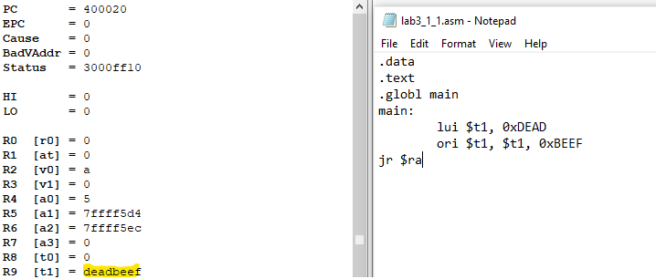

* 1. Redo 1.1 as follows: use **ori** to load each letter into register. (**lab3_1_2.s**)

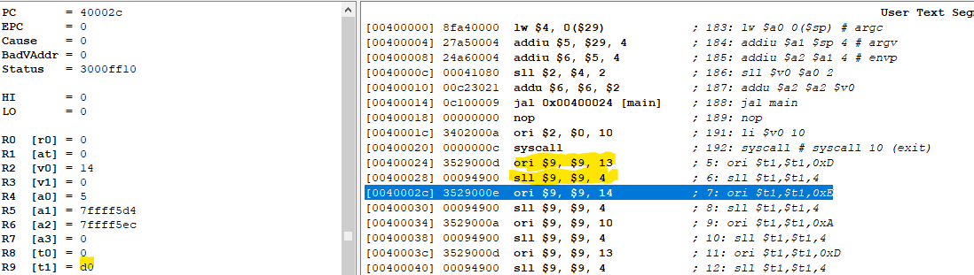

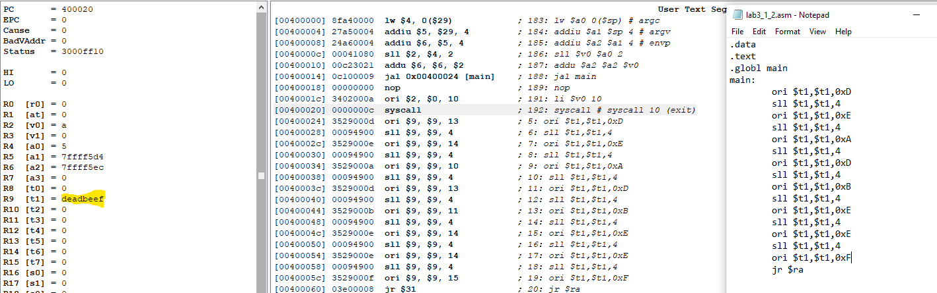

* 1. Suppose that $t1 = 0xDEADBEEF. Using only register-to-register logic and shift instructions, Reverse the order of the bytes in $t1 so that register $t2 get the bit pattern 0xFEEBDAED. (**lab3_1_3.s**)

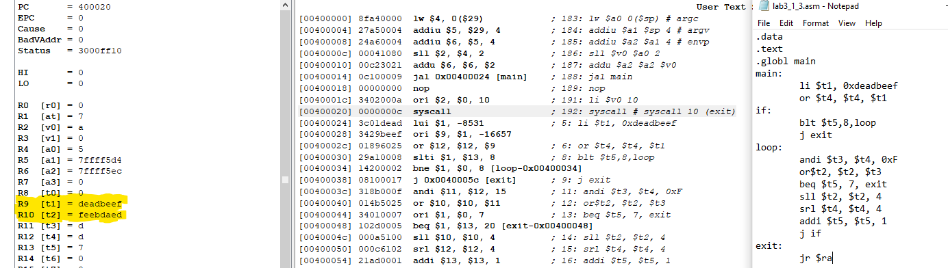

* 1. Redo 1.3 using only **and**, **or**, and rotate instructions. (**lab3_1_4.s**)

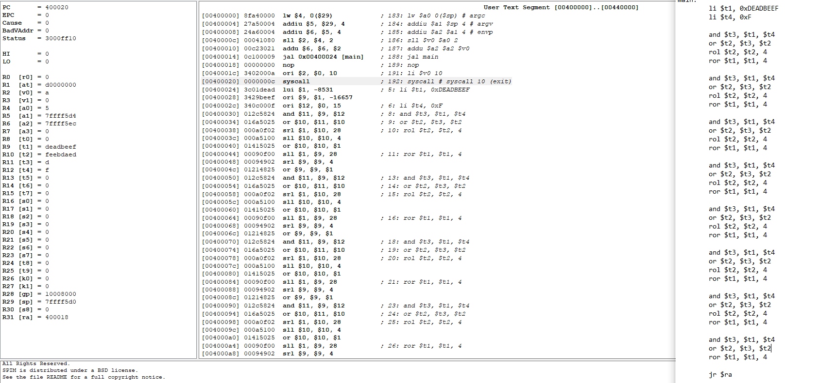

1. **Exercise 2: (15pts) Write a program that**
   1. Set the corresponding bit in register $t1 through $t8. That is, in register $t1 set bit 1, register $t2 set bit 2, and so on. (**lab3_2_1.s**)

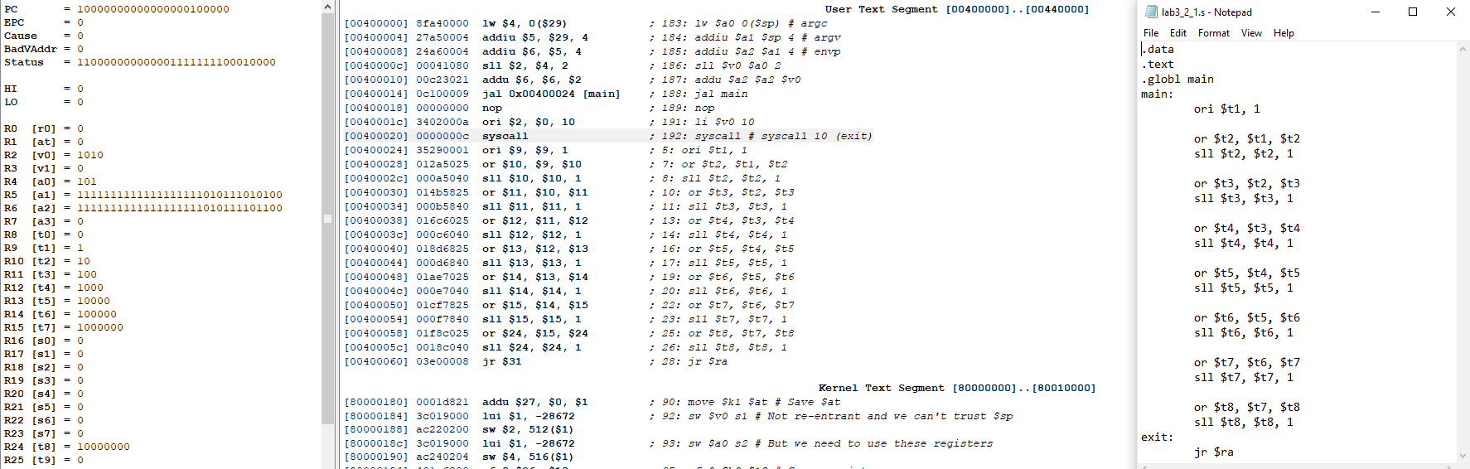

* 1. By using **ONLY** shift instructions and register to register logic instructions (no **li** pseudoinstruction or **addi**), put the pattern 0xFFFFFFFF into register $t1. (**lab3_2_2.s**)

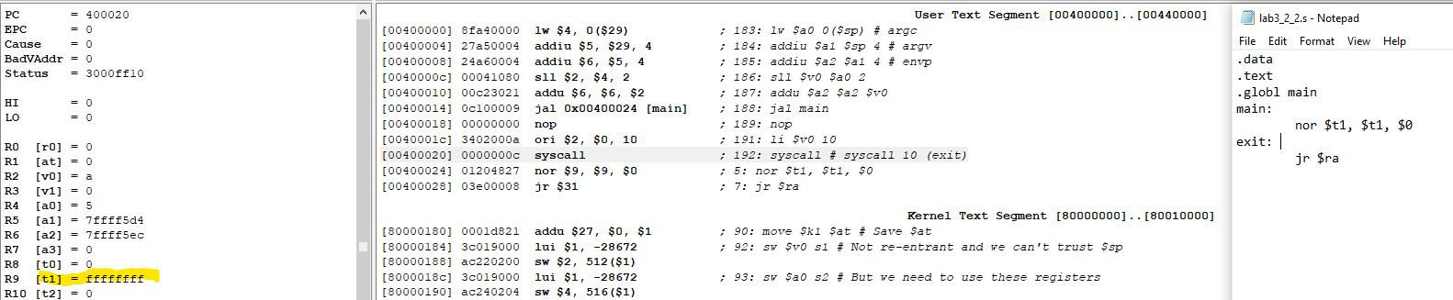

1. **Exercise 3: (20pts) Write a program that**
   1. Read in **ONE** unsigned integer in the range 0 to 15. Print out that number in hexadecimal. For example, given the input 13, print out 0xD. (**lab3_3_1.s**)
   2. Modify the previous assembly, create a procedure printHex(int num). This procedure takes in a number and print it out in hexadecimal. (**lab3_3_2.s**)
   3. Modify the previous assembly so that it can print out hexadecimal of any 32-bit integer input. For example, read in number 546263, print out 0x855D7. (**lab3_3_3.s**)

# **II. MSP430 (30pts)**

Given a sample code to control LED via pushing button in MSP430 as follows

|  |  |  |
| --- | --- | --- |
| **No.** | **Sample codes** | **Comments/Results/Functions** |
| **1.**  **2**  **3**  **4**  **5**  **6**  **7**  **8**  **9**  **10**  **11**  **12**  **13**  **14**  **15**  **16**  **17**  **18**  **19**  **20**  **21**  **22**  **23**  **24**  **25**  **26**  **27**  **28**  **29** | **#include** <msp430.h>  **#define** Red BIT0  **#define** Green BIT6  **#define** Button BIT3  **void** **main**(**void**) {  WDTCTL = WDTPW | WDTHOLD;  P1OUT |= Red;  P1OUT &= ~Green;  P1DIR |= Red +Green;  P1DIR &= ~Button;  P1REN |= Button;  P1OUT |= Button;  **while**(1)  {  **if** ((P1IN & Button)!= Button)  {  **while** ((P1IN & Button)!= Button)  {  }  P1OUT ^= Red + Green;  }  }  } |  |

**Step 1:** build the sample code in CCS, check the errors.

**Step 2:** **Not run**, the values of these registers (PORT_1_2):

P1OUT:

P1IN:

P1DIR:

P1REN:

P1IFG:

**Step 3:** Run, observe and collect the values of these registers in case of

|  |  |  |
| --- | --- | --- |
|  | **Red LED On** | **Green LED On** |
| P1OUT |  |  |
| P1IN | 0x0F=0000111 |  |
| P1DIR |  |  |
| P1REN |  |  |
| P1IFG |  |  |

Comment and explain the Table above: **________________________________________________________________________________________________________________________________________________**

When running and pausing, click View and open ***Disassenbly*** window, write down **these instructions of sample code above:**

|  |  |  |
| --- | --- | --- |
| **No.** | **C code** | **MIPS code** |
| **1.**  **2**  **3**  **4**  **5**  **6**  **7**  **8**  **9**  **10**  **11**  **12**  **13**  **14**  **15**  **16**  **17**  **18**  **19**  **20**  **21**  **22**  **23**  **24**  **25**  **26**  **27**  **28**  **29** |  |  |

Based on the Table above, **please explain the process of sample code under if-then else conditional statements:**

**________________________________________________________________________ _______________________________________________________________________________________________________________________________________________________________________________________________________________________ _______________________________________________________________________________________________________________________________________________**

## **Problem 1: modify the sample code in order to when pressing the button two LEDs turn on and vice versa.**

**Your code:**

**Reference:**

1. <https://en.wikibooks.org/wiki/MIPS_Assembly/Pseudoinstructions>
2. <https://courses.missouristate.edu/KenVollmar/MARS/Help/SyscallHelp.html>
3. <https://www.assemblylanguagetuts.com/mips-assembly-programming-tutorials/#MIPS_Data_Types>
4. <https://en.wikibooks.org/wiki/MIPS_Assembly/Arithmetic_Instructions>
5. <https://gab.wallawalla.edu/~curt.nelson/cptr280/lecture/mips%20arithmetic%20instructions.pdf>